Game Lab 8 Detecting A Tank Collision

Possible collision Scenarios
We must detect a collision between our tank objects and program our environment to react accordingly. One simple method is to mark all possible collisions i.e. with 2 tanks in 4 directions there will be 16 possible with 8 possible directions there will be 64.
We may mark each possible collision position with, for example, an integer value i.e. Collision Position.

For example, with a head on collision with one tank1 in trajectory 1 and tank2 in trajectory 2
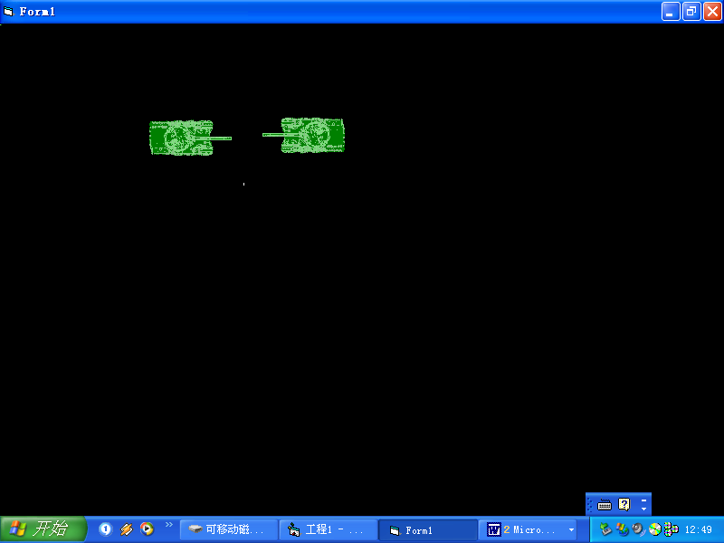

If the trajectory of Tank1 is right and trajectory of tank 2 is left
Mark the collision position as 1

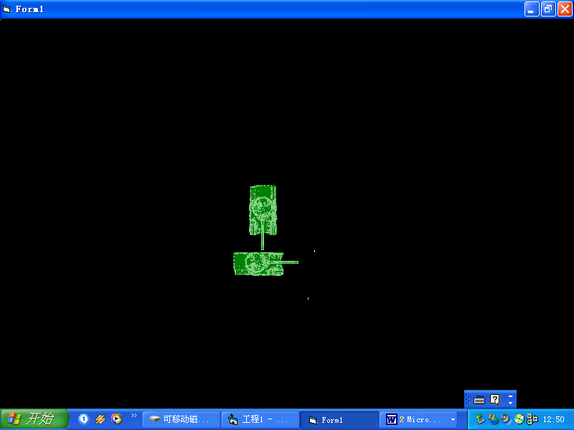
When coming down (or going up collision it does not matter if the other tank is in trajectory 1 (facing left) or trajectory2(facing right). The calculation will be the same. This can cut down the amount of cases there will be for different collision code.
Pseudocode:

If (P1 TRAJECTORY is down ) And ((P2 TRAJECTORY is left) Or (P2 TRAJECTORY is right)) Then
COLLPOS = 3
End If
….

‘Coming Up is similar

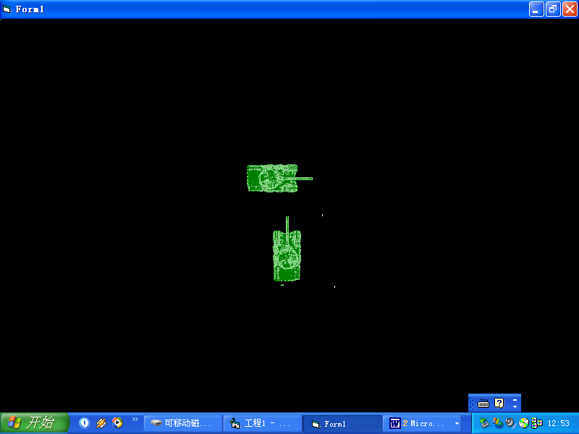

Another scenario is coming across with both facing the same way
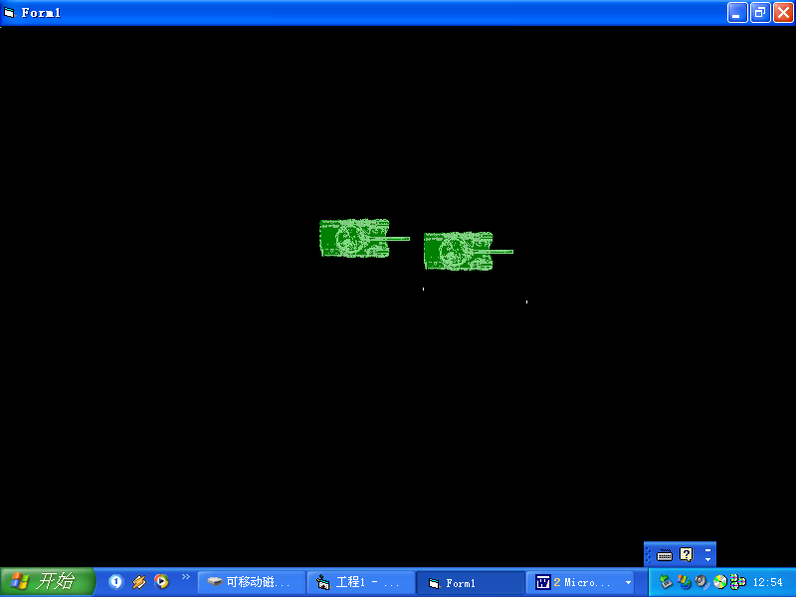
The tanks in facing the same way may be facing up, down left or right.

Calculating Whether a Collision has Taken Place

Once the collision position is set using the tank trajectories we may use it to calculate whether there has been a collision of the tanks

Select Case COLLPOS

Case tank 1 moving left and tank 2 moving down:

x,y
a,b

Test the X co-ordinates for overlap:
If (x < a) AND (x + image width > a)

Code example:
if ((pictureBox1.Left < pictureBox2.Left) && (Picturebox1.Left +(PictureBox1.Width > pictureBox2.Left)));
// this places the position of one tank overlapping the other for the x coordinate

Test the Top co-ordinates for overlap:

if (y>b) AND (y < b + image Height )

if ((pictureBox1.Top > pictureBox2.Top)&& (pictureBox1.Top < (pictureBox2.Top + pictureBox2.Height)))
// this places the Y position of one tank overlapping the other

if the X and Y co-ordinates overlap then there is a collision and we must move the tanks appropriately:

In this case the X coordinate i.e. the left property is changed, for example:
a = a + 20
x = x - 20

Work out the other possibilities and write the code.

Sample Collision Code :

private void TestCollision(){
//Tank1FACELEFT_Tank2FACERIGHT
if((pictureBox2.Left + pictureBox2. Width) > pictureBox1. Left)

if (pictureBox2. Left < (pictureBox1. Left + pictureBox1. Width))

if ((pictureBox2. Top + pictureBox2. Width) > pictureBox1. Top)

if(pictureBox2. Top < (pictureBox1. Top + pictureBox1. Height))

{

pictureBox1. Left = pictureBox1. Left - 20);
pictureBox2. Left= pictureBox2. Left + 20);

}

///Tank1FACEDOWN_Tank2FAceup

if((pictureBox1.Left + pictureBox1.Width) > pictureBox2.Left)
if (pictureBox1.Left < (pictureBox2. Left + pictureBox2.Width))
if ((pictureBox1.Top + pictureBox1. Width) > pictureBox2.Top)
if (pictureBox1.Top < (pictureBox2.Top + pictureBox2.Height))
{
pictureBox1.Top = pictureBox1.Top - 20;
pictureBox2.Top = pictureBox2.Top + 20;

}

